

**Discipline**

**Create S3 bucket using CLI and Perform given actions**

**CS5002**

Activity-9

**Sheikh Muhammed Tadeeb (AU19B1014)**

* **Problem Statement:**

Create a new S3 Bucket in Us-east-1 region and upload 3 files from laptop/desktop, and show the object along with S3 bucket via CLI.

* **Solution:**

**Step -1:** Login to IAM user via CLI

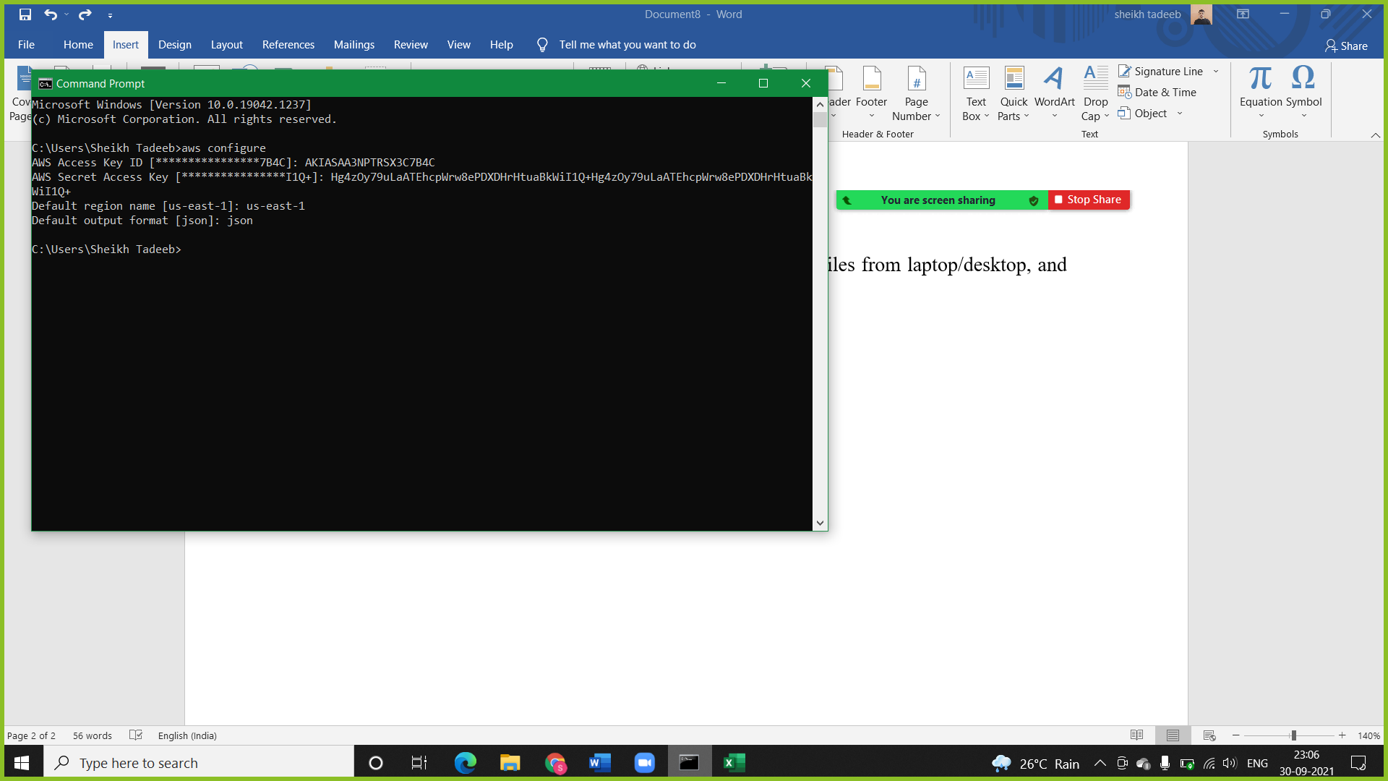

CMD: ***aws configure***

(The above command will login to the IAM user).

**Step -2:** Create bucket for that user

CMD: ***aws s3 mb s3://tadeebcli --region us-east-1***

(The above command create bucket using mb in s3://bucketname and specified region.)

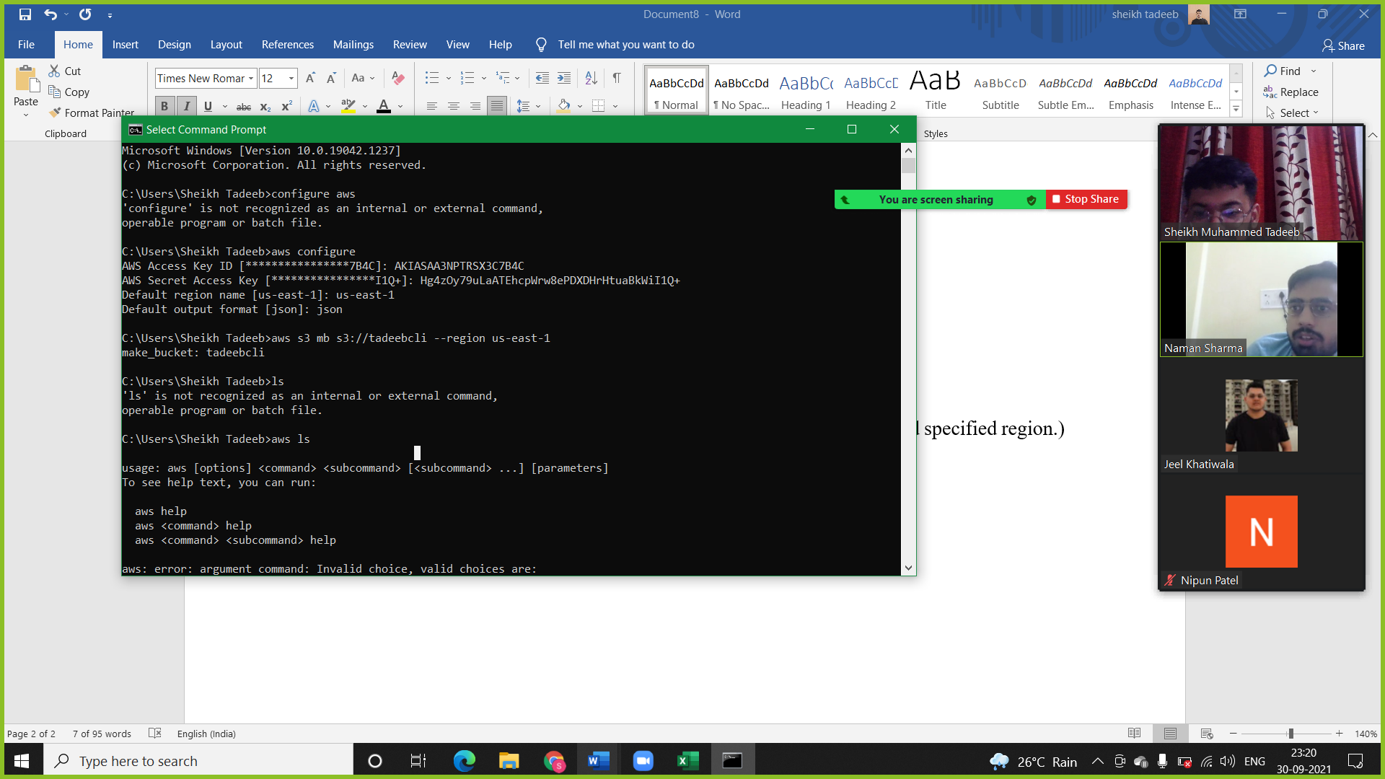

**Step -3:** Add 3 files to the bucket we created naming tadeebcli.

CMD: ***aws s3 cp “filename” s3://tadeebcli***

(The above command copies system file into bucket using cp filename in s3://bucketname.)

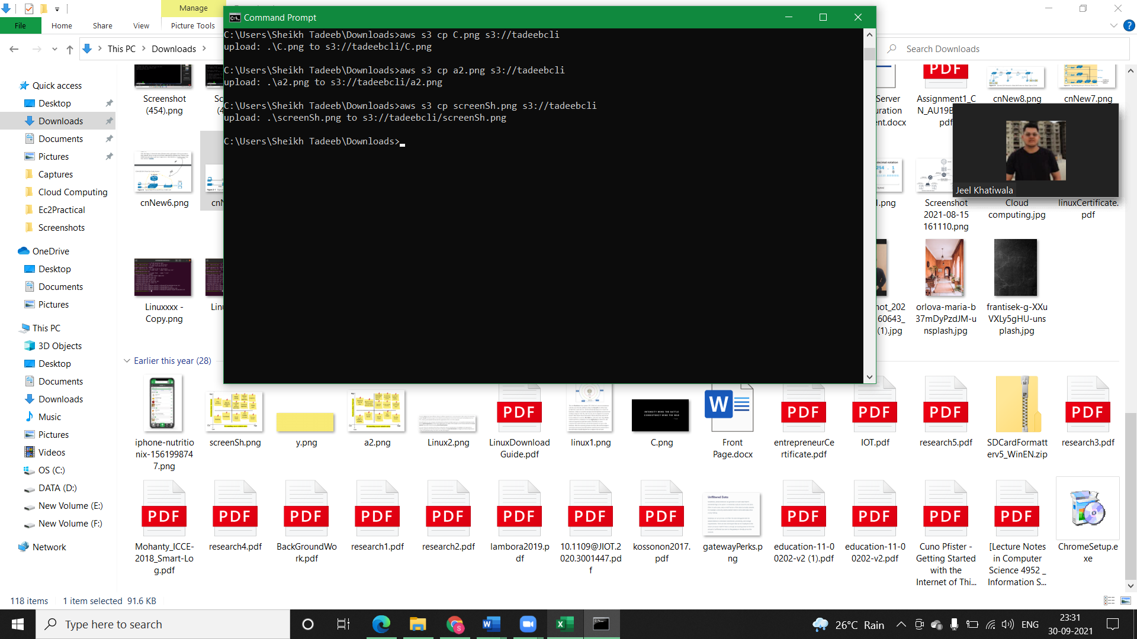

**Step -4:** Show the files we added in our bucket tadeebcli

CMD: ***aws s3 ls s3://tadeebcli***

(The above command shows bucket objects using ls in s3://bucketname.)

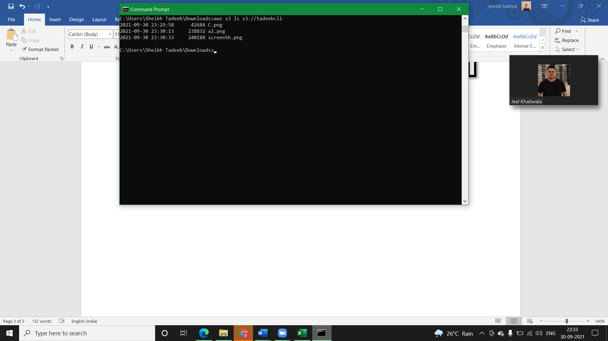

* **Verification of the command operations:**

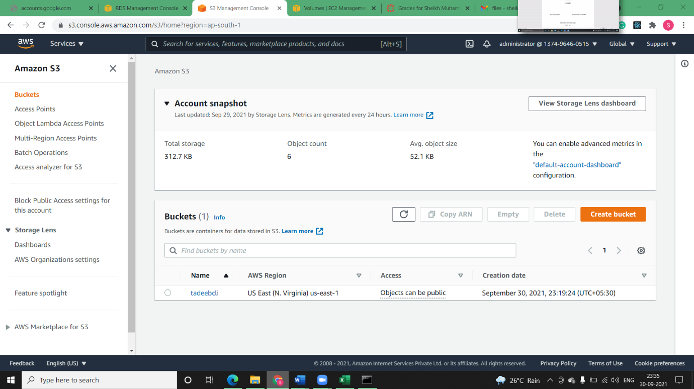

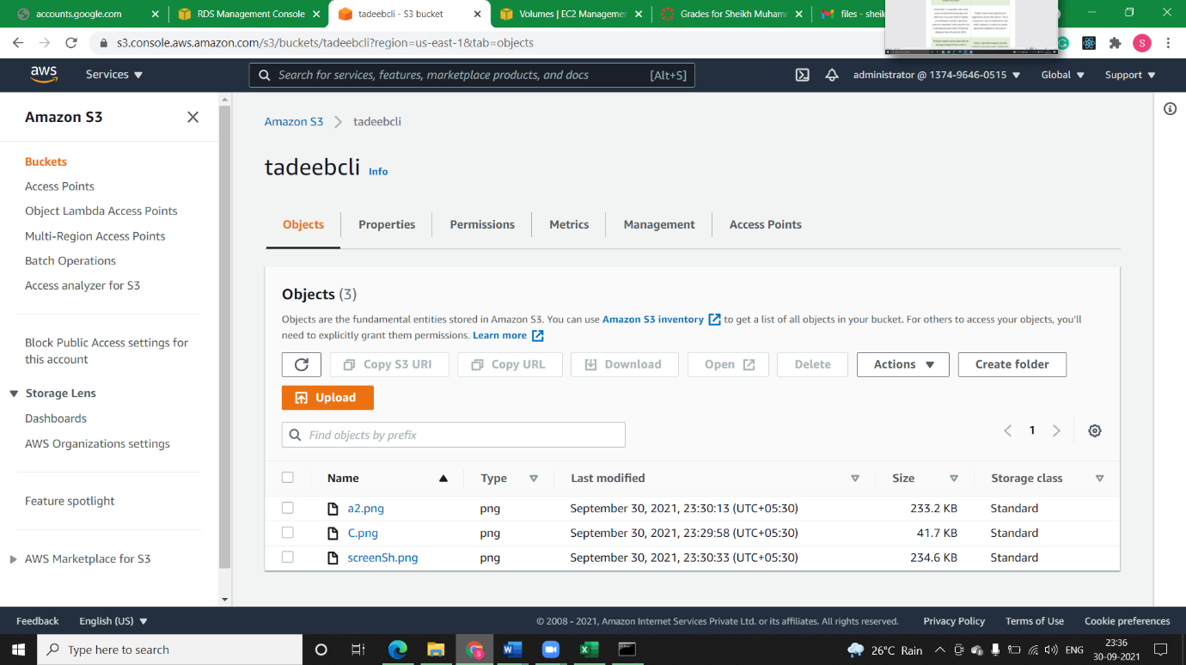

Hence the bucket is created successfully and all the files were added to the bucket we created, thus our operation via CLI creation is successful.